Rafael Canseco

SNHU

CS-340

Intructor Felicia Rosemond

09/08/24

Assignment 1-3: Intro to MongoDB

Verifying presence in Mongo Shell:

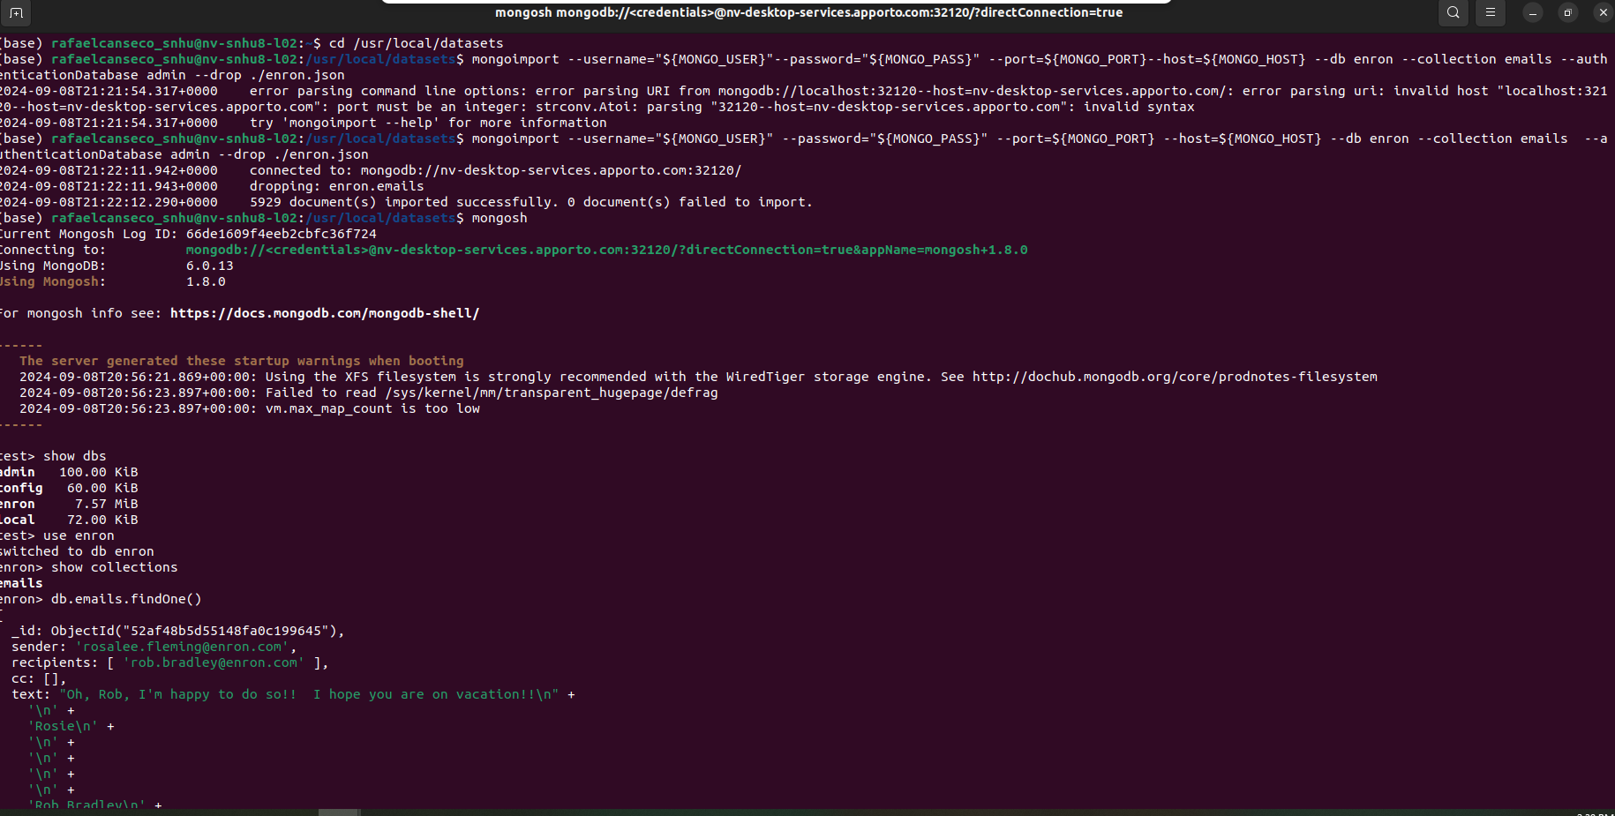

Show dbs/Use of eron/show collections:

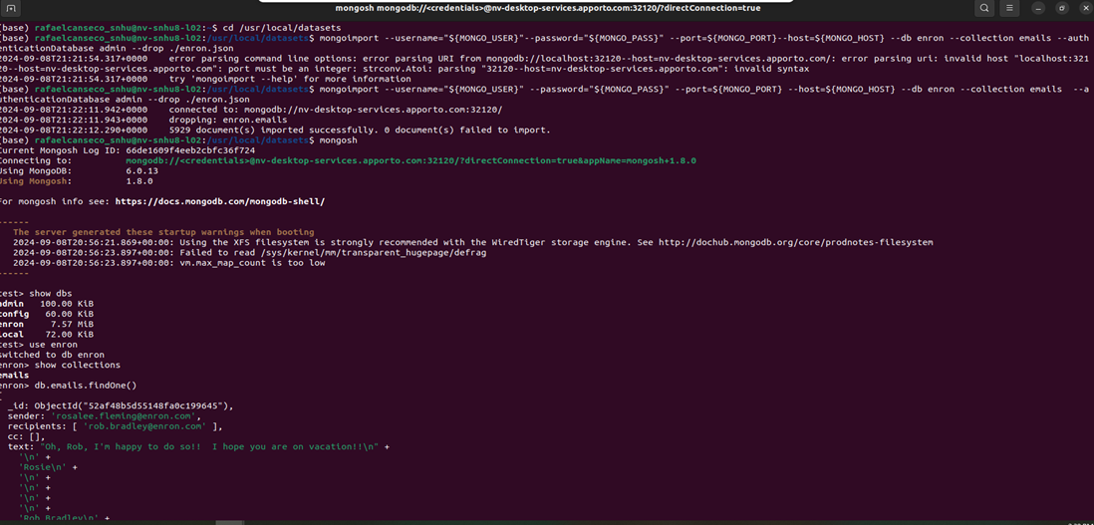

Db.emails.findOne():

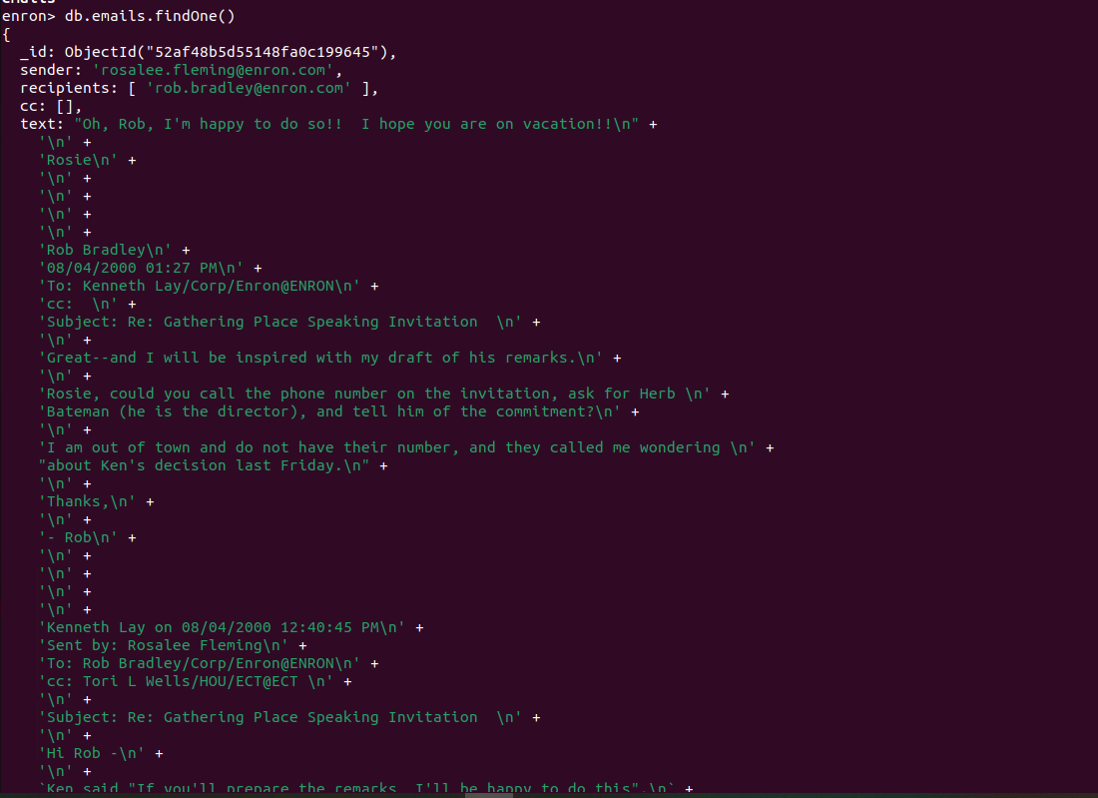

Installing mongocompat and finding the size of a single doc:

Finding the size of the collection of doc:

